We can create report by using surefire plugin in POM.xml. For this we need to have suiteXmlFiles

for example:

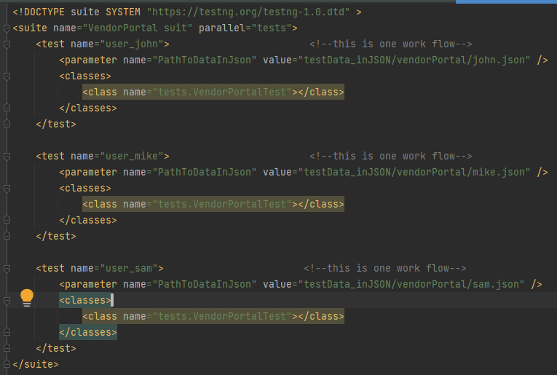

POM.xml well look like this.

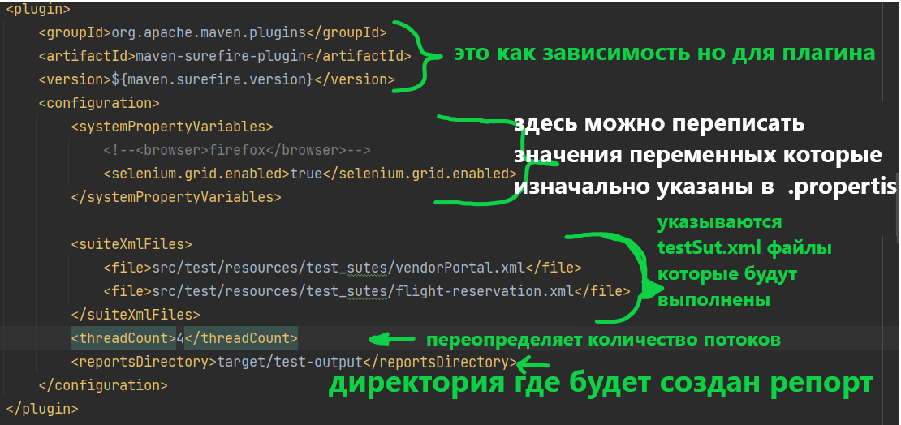

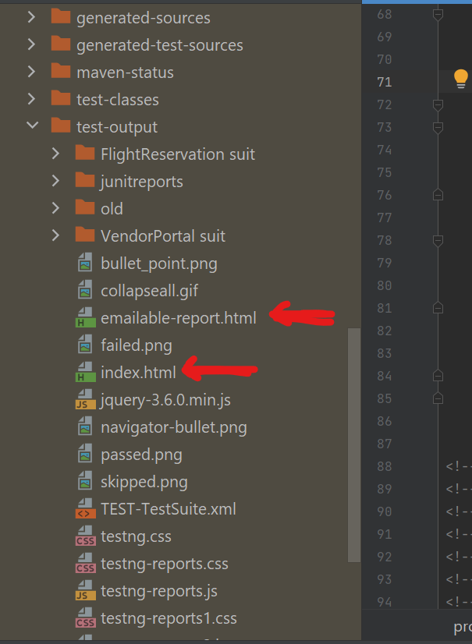

The report will look like this

we can open in browser html documents and see the details

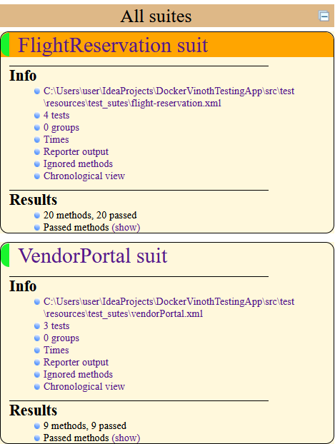

one of them will look like this

Также читай о рипортах тут.

https://drive.google.com/drive/u/0/folders/15UTnPinzhlyysvfcaR7TlRWGqEKEFp1Q